Ministry of Higher Education and Scientific Research

And Information and Communication Technologies

Générale Direction of Technologies studies

**Higher Institute of Technologies studies of Bizerte**

**Information Technology Department**

**INTEGRATION PROJECT REPORT**

Subject: Development of purchasing and sales applications

**Realized By:** Sprint Squad

**Supervising teacher:** Miss Afef Gafsi

**Academic year: 2023-2024 DSI31**

**Summary**

General Introduction 1

Chapter 1: Preliminary study 2

Introduction 2

1.1. Description of existing equipment 2

1.2. Existences Criticisms 2

1.3. Proposed Solution 2

1.4. Adapted working method. 3

a SCRUM project management method 3

b Done criteria 3

c Sprints Time Box 3

1.5. Working tools 3

a Frameworks used 3

b Software development 4

Conclusion 6

Chapter 2: Product Backlog planning 7

Introduction 7

2.1. User’s identification 7

2.2. User Stories 8

2.3. Application Flows 9

2.4. Product Backlog 9

Conclusion 11

Chapter 3: Sprint 1 12

Introduction: 12

3.1 Sprint objective 12

3.2 Sprint backlog 12

3.3 Sprint 1 implementation 14

a Requirement descriptions phase 14

**List of figures**

Figure 1: NodeJS and Express 4

Figure 2: Android Native with kotlin 4

Figure 3: Spring boot logo 4

Figure 4: VsCode logo 5

Figure 5: Android Studio logo 5

Figure 6: IntelliJ ide logo 5

Figure 7: Postman logo 6

Figure 8: Github logo 6

Figure 9: Application browsing flow 9

Figure 10: Participants Class Diagram 15

Figure 11: Iterations Diagram 16

**List of Tables**

Table 1: Product Backlog 9

Table 2: Sprint 1 backlog 12

# General Introduction

# Chapter 1: Preliminary study

## Introduction

In this chapter, we are going to present the different functionalities of our application, as well as its critics, the proposed solution and a detailed description of the final solution.

## Description of existing equipment

In the current method of selling and buying products, the customer or supplier has to go to a store or company or someone to buy a product on the spot, talk to them, and all transactions between them are done through documents such as purchase orders, and they receive money hand over fist.

## Existences Criticisms

In the current system, to purchase products there is some criticisms like:

* No availability: customers need to contact the seller to arrange a meeting when they are available.
* Wasting time and money: They must then arrange transportation, and sometimes unforeseen issues may prevent them from completing the transaction, resulting in wasted time and money
* Scamming and fraudulent activities: There is no customer service available, which has led to a significant number of scams and fraudulent activities. Customers cannot feel secure because they must carry cash with them to make purchases, putting them at risk of theft.

## Proposed Solution

Create an application that allows users to buy and sell products from each other. This project offers users features such as registration and login, adding products from the seller for sale, the customer can buy products and put them in a wish list, online payment after product verification. Our application also offers a badge and reward system, enabling sellers to establish a relationship of trust with their customers, as well as a feature for contacting the admin or seller, if there are any problems. This is a project that can be developed using android with kotlin and using a microservices architecture with NodeJS and express and spring boot using MEAN stack technology.

## Adapted working method.

### SCRUM project management method

For the development of our projects, we are decided to choose SCRUM like a method of the project management with:

* Miss Afef Gafsi: the Scrum master which she is the responsible to help us to move forward independently, while constantly striving to improve.
* Developers: We are playing the developers roles that we are supposed to developing the different apps and architectures of it.
* Product Owner

### Done criteria

We are supposed that a user story is done, it should be terminated and work fluently.

### Sprints Time Box

We take as an estimation for every sprint 2 weeks.

## Working tools

### Frameworks used

During the development of our project, we are using a variety of Frameworks like:

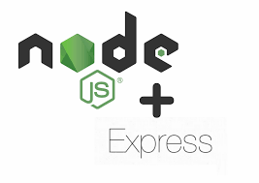

Figure 1: NodeJS and Express

We are using NodeJS and Express for developing micro services, for the web version.



Figure 2: Android Native with kotlin

To developing the mobile version of our application we are using the android native with kotlin as a programming language.



Figure 3: Spring boot logo

We are also using Spring boot for the developing of the micro services for the web version.

### Software development

For the developing of our application, we are using a variety of software programs like:



Figure 4: VsCode logo

For the development of NodeJS and Express, we are decided to use VsCode.



Figure 5: Android Studio logo

For the development of the mobile version we decided to use android studio.



Figure 6: IntelliJ ide logo

For the development for the micro services in spring boot we decided to use IntelliJ ide



Figure 7: Postman logo

We are using Postman for testing the API of the backend which develops with NodeJS express and SpringBoot.



Figure 8: Github logo

We are using Github for colloaborating and for coding as a teams, means everyone have a code deploying in github and he can change whenever he want.

## Conclusion

In this chapter we’ve presented a preliminary study of our application, we’ve presented the organization's need for this application as well as its benefits, we’ve also presented all the system's functionalities.

# Chapter 2: Product Backlog planning

## Introduction

In this chapter, we are going to present the different actors and their user’s stories, then we are going to present the product backlog.

## User’s identification

In this application we’re developing different functionalities for 3 actors:

A seller he has functionalities:

* Managing his products that he would buy.
* Check his activities and his profits in the year.
* Showing showcased badges in his profile to keep in trust with customer.
* Keep in contact with admin if there is a problem.

A customer has functionalities:

* Managing his favorite products in his Wishlist.
* Pay money after verification of the product.
* Keep in contact with admin or the seller if there is a problem.
* Track his shipments.
* Review seller’s services.
* Pass an order.
* Add a strike to a seller if he doesn’t like his services.
* Search for products respond of a various criteria.

And an admin has functionalities:

* Ban a user if he got 3 strikes.
* Verificate customer’s strikes.
* Managing the categories of the products.

## User Stories

## Application Flows

Figure 9: Application browsing flow

## Product Backlog

Table 1: Product Backlog

|  |  |  |  |  |  |  |  |
| --- | --- | --- | --- | --- | --- | --- | --- |
| N° | Description User story | Type | Priority | Complexity | Estimate | Acceptance criteria | Sprint |
| 1 | As a developer, I initialize the project with the necessary dependencies to properly manage the application. | TS | 1 | Low | 1 day | Functional project | 1  Initialization  Project  And category Crud and product’s  seller  Crud |
| 2 | As an admin I would like to add a category | US | 1 | Medium | 2 days |  |
| 3 | As an admin I would like to delete a category | US | 1 | Low | 2 days |  |
| 4 | As an admin I would like to modify a category | US | 1 | Medium | 2days |  |
| 5 | As a seller I would like to add a product in my shop | US | 1 | Medium | 2 days | adding successfully |
| 6 | As a seller I would like to delete a product in my shop | US | 1 | Low | 2 days | deleting successfully |
| 7 | As a seller I would like to modify a product detail in my shop | US | 1 | Medium | 2 days | modifying  successfully |
| 8 | As a user I would like to see all the product in the application | US | 1 | Low | 1 day | Showing products successfully |  |
| 9 | As a customer I would like to check a product detail and it price | US | 2 | Low | 1 day | Showing products details successfully | 2  Crud’s products in customer’s  Wishlist and pass orders |
| 10 | As a customer I would like to search for a product using a various criteria | US | 2 | Medium | 2 days | Searching successfully |
| 11 | As a customer I would like to add a product in my wishlist to buy it later | US | 2 | Medium | 2 days | Adding successfully |
| 12 | As a customer I would like to delete a product in my wishlist | US | 2 | Low | 1 day | Deleting successfully |
| 13 | As a customer, I would like to pass an order to a product | US | 2 | Medium | 2 days | Orders passed successfully |
| 14 | As a customer, I would like to verficate the qualities of products before paying | US | 2 | Medium | 2 days | Verification successfully |
| 15 | As a customer, I would like to pay for the product online | US | 2 | Medium | 2 days | System of payment working successfully |
| 16 | As a customer, I would like to track my shipment | US | 2 | Medium | 2 days | Shipment tracked successfully |
|  | As a developer I developing a system of earnings badges to who’s have send 5 successful tracks | US | 3 | Medium | 1 day |  | 3  Authentification  Reviewing, badges system  And user’s statics |
| 17 | As a customer I would like to review the services of sellers | US | 3 | Medium | 1 day |  |
| 18 | As a customer I would like to add strikes if I don’t like a service of sellers | US | 3 | Medium | 1 day |  |
| 19 | As an admin, I would like to verificate the strikes after user’s add | US | 3 | Medium | 1 day |  |
| 20 | As an admin, I would ban sellers if he got 3 strikes | US | 3 | Medium | 1 day |  |
| 21 | As a seller, I want to showcase earned badges to build trust with buyers. | US | 3 | Medium | 1 day |  |
| 22 | As a user, I want to see badges on the profiles of other users or sellers | US | 3 | Medium | 1 day |  |
| 23 | As a user, I want to view the transaction history with real-time tracking data. | US | 3 | High | 2 days |  |
| 24 | As a seller I would like to check my profits in the year | US | 3 | High | 2 days |  |
| 25 | As a customer I would like to contact the seller or the admin if there is a problem | US | 3 | High | 3 days |  |
| 2 | As a user, I would like to authenticate to get an access to my space in the app | US | 1 | Medium | 4 days | Authentication  successfully |  |

In our project we got 3 sprints, the one of it releasing during 2 weeks:

* Sprint 1: Initialization project, Authentication and product’s seller Crud.
* Sprint 2: Crud’s products in customer’s wishlist and pass orders.
* Sprint 3: Reviewing, badges system and user’s statics.

## Conclusion

In this chapter, we’ve presented all the user stories related to our projects, also we’ve presented all the user’s identifications, and finally we’ve presented the product backlog classified by sprints.

# Chapter 3: Sprint 1

## Introduction:

In this chapter, we are going to present the sprint backlog, the implementation, and the different diagrams and conceptions.

## Sprint objective

During this sprint, we are supposed to implement a system of user’s authentication to managing their roles, also we are supposed to add a system to let the seller to manage their products that he would buy.

## Sprint backlog

Table 2: Sprint 1 backlog

|  |  |  |  |  |  |  |  |
| --- | --- | --- | --- | --- | --- | --- | --- |
| # | User Story | Tasks | Owner | Estimation | Start | In progress | Done |
| 1 | As a developer, I initialize the project with the necessary dependencies to properly manage the application. | Install the developing environments | All members | 15 hours |  |  | X |
| Install the project and all their dependencies | 9 hours | X |  |  |
| 4 | As an admin I would like to add categories for products | Create all the necessary models in the database and in the project | Farouk | 15 hours | X |  |  |
| Create a user interface | Jasser | 9 hours | X |  |  |
| Create an add category controller | Ahmed | 1 day | X |  |  |
| 5 | As an admin I would like to delete categories for products | Create a delete button in the user interface | Haythem | 1 hour | X |  |  |
| Create a delete category controller | 23 hours | X |  |  |
| 6 | As an admin I would like to modify a category | Create a user interface | Farouk | 1 jour | X |  |  |
| Create an edit category controller | Bayrem | 1 jour | X |  |  |
| 6 | As a seller I would like to add a product in my shop | Create all the necessary models in the database and in the project | Hakim | 15 hours | X |  |  |
| Create a user interface | Bayrem | 9 hours | X |  |  |
| Create an add product controller | Ahmed | 1 day | X |  |  |
| 7 | As a seller I would like to delete a product in my shop | Create a delete button in the user interface | Jasser | 1 hour | X |  |  |
| Create a delete product controller | 23 hours | X |  |  |
| 8 | As a seller I would like to modify a product detail in my shop | Create a user interface | Hakim | 1 day | X |  |  |
| Create an add product controller | Ahmed | 1 day | X |  |  |

## Sprint 1 implementation

### Requirement descriptions phase

In this part we’ll going to describe the user descriptions of what he needs and also, we are going to modelized that in diagrams “Use Case, Participants Class and Iterations diagram”.

* Use Case diagram.
* 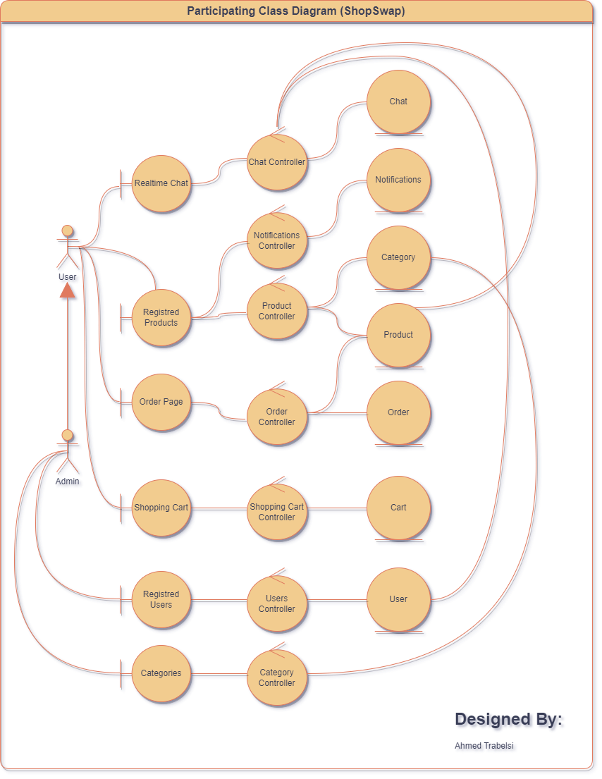Participants Class Diagram

Figure 10: Participants Class Diagram

Ce diagramme de classes participantes offre une représentation détaillée des différentes catégories de classes (Boundary, Control, Entity) et de leurs interactions au sein du système "Shop Swap". Il aide à comprendre comment les classes interagissent pour permettre des fonctionnalités telles que l'inscription, la connexion et la gestion des utilisateurs et des produits.

* Iterations diagram

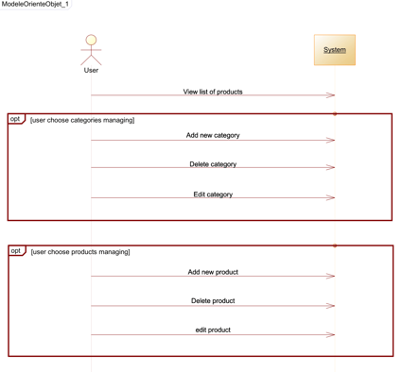

Figure 11: Iterations Diagram

In this diagram we are describe the interactions between user and system in all the first sprint like the subscribe the login, the verifications of roles and what user’s role can do like the admin and the seller, and also, we describe all the possible case like when there is errors of login or subscribe.